

**Name: Nikhil Bhagasra**

**Section:** KM012

**Registration Number:** 11718931

**Roll Number: 35**

**Assignment Name:** CA-02

**Assignment Submitted To: Neha Sharma**

JUGAD - Your Local Shipping Company

Jugad is an shipping company website where a user can create thier account and create a request based on the services the requires. The basic idea for this project came when student in our college started providing clock room and shipping services for your luggage in the lpu hostel.jugad is a nodejs website to make the shipping request easier.

The user can create an account and generate the shipping request or clock room services based on thier needs. Jugad is also a reponsive website.

**HOME PAGE:  
JUGAD**



This is our home page to direct the traffic and tell the user about the company. There aren't many aspect in this aspect page except the login sign up form and the feedback form which we will discuss about in the later page.

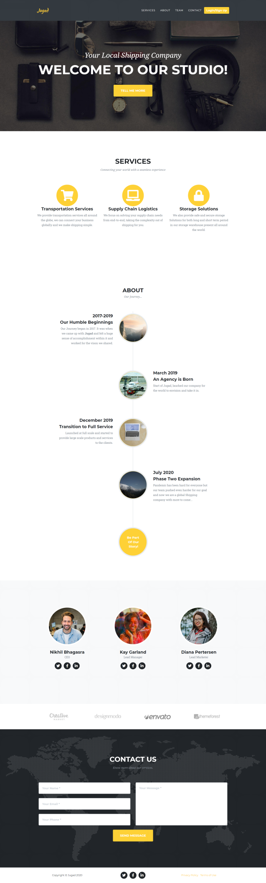

**LOGIN FORM**

This is the login form of the jugad which give access to 2 modules 1st is admin and the 2nd is for the registered user. The admin module gets all the details about the order and users. And the user module can be used for placing the shipping order or checking the past records of the orders.

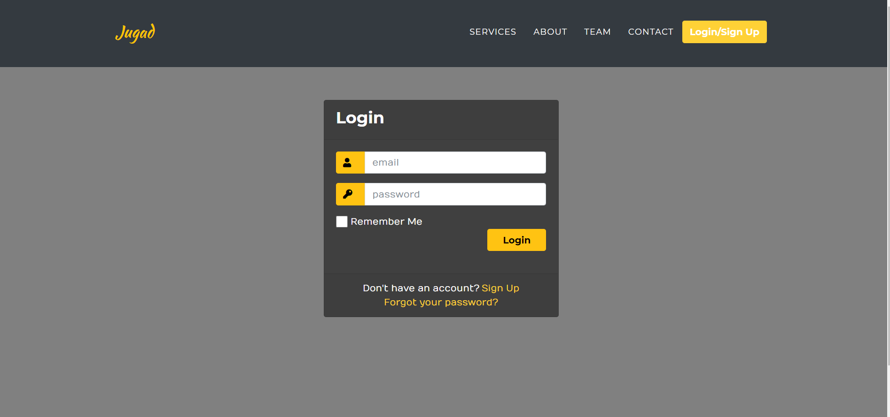

**SIGN UP FORM**

This is the sign up form of jugad it is used to create a new user and save thier details in the database which will be used for them to login into the app.

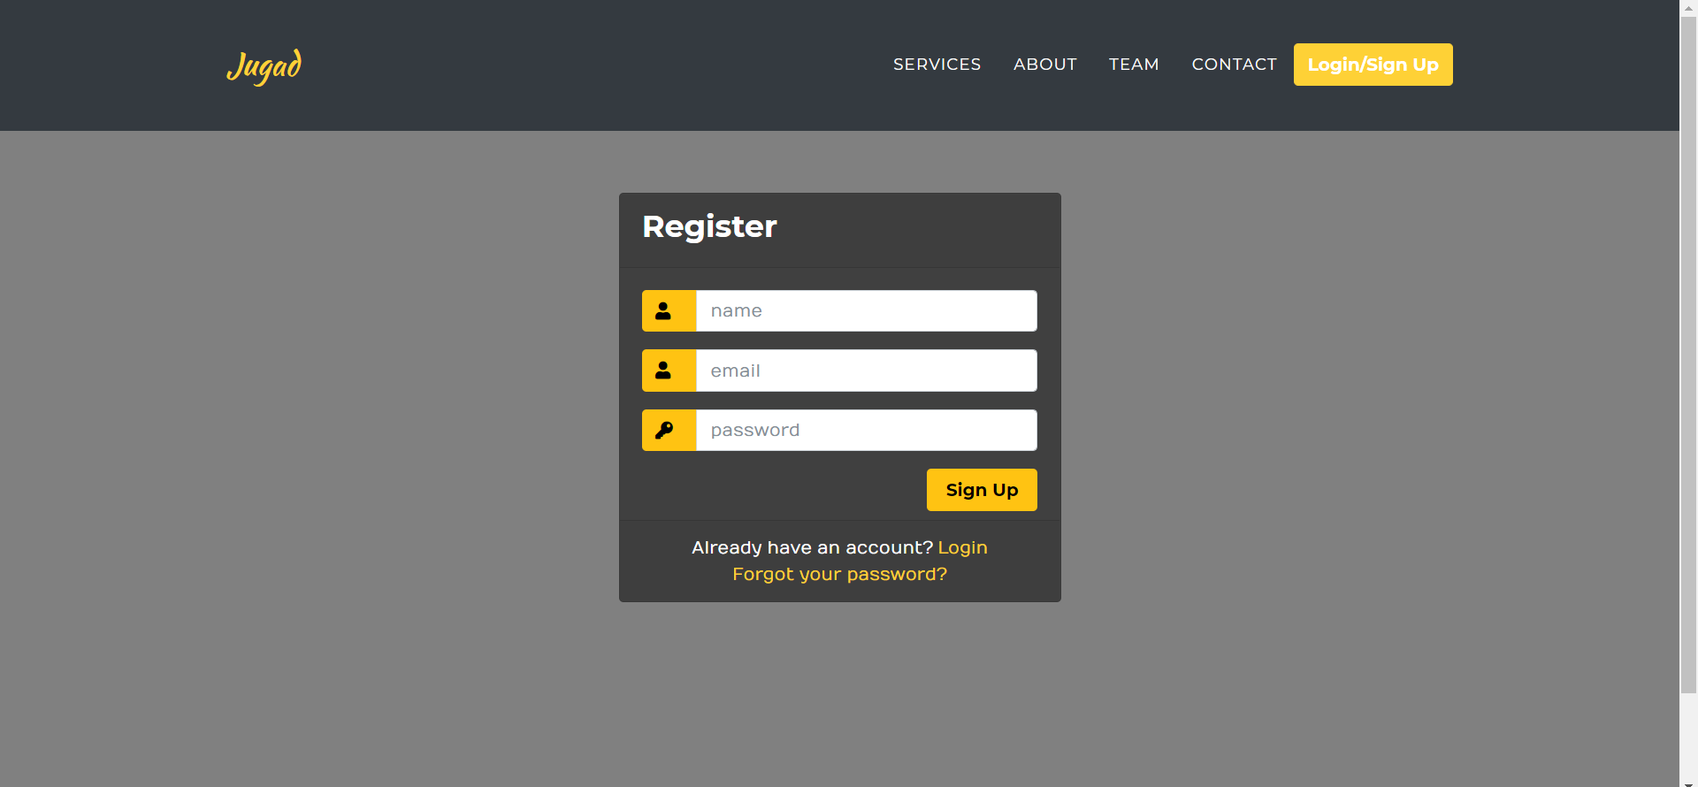

**CONTACT US FORM**

The Contact us form is present at the bottom of the home page in which you can ask any inquires or give feedback related to our work and it will be shown in the contact form section of the admin page.

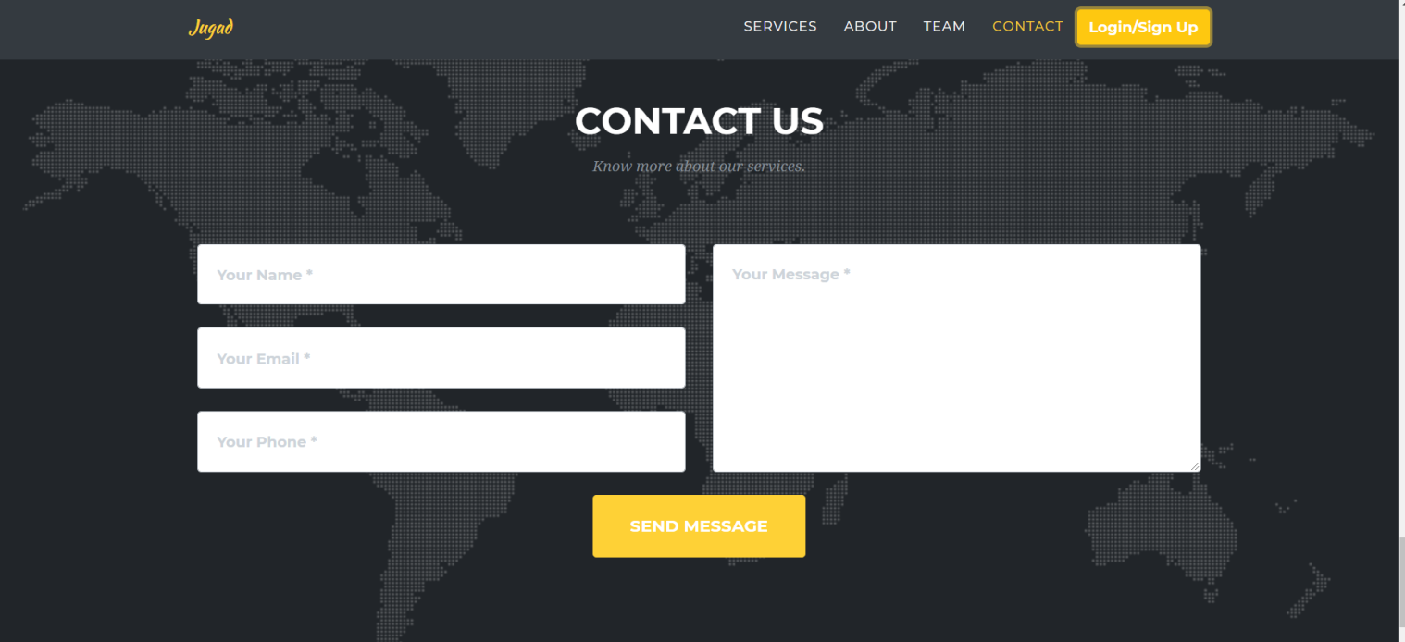

**NEW USER ORDER PAGE**

This is the first page of a new user from where he can avail the services which he feel the need for and the list of all the availed services can be seen in the my orders section of the user.

